Title: Spatial analysis with map algebra

What you will learn:
- Apply map algebra for raster analysis.
- Distinguish Boolean, discrete, and continuous data
- Make legends for Boolean, discrete, and continuous maps
- Calculate distances from rasters
- Reclassify rasters
- Convert rasters to vector points
- Sample raster values with vector points

Resources:
- Data for this exercise is in the data8 folder (UNZIP the folder after downloading).
Laboratory Exercise:
The municipality of the (imaginary) oasis Orangeville has hired you to analyze which wells are suitable for its inhabitants based on the following conditions:

Condition 1: The wells should be within 150 meters of houses or roads.
Condition 2: No industry, mine, or landfill within 300 meters of the wells.
Condition 3: The wells should be less than 40 meters deep.

For this exercise, you will use rasters made up of pixels (or grids) containing some values. Raster data can be:
- Discrete – data with qualitative values (or categorial) where the number in each pixel represents a class or category, such as land use and soil type.
- Continuous – data with quantitative values, for instance, elevation and temperature. Numbers in pixels represent the actual values of the variables.
- Boolean – contains two values: 1 for true and 0 for false.

You will use four base raster layers in this exercise:
- buildg.tif – location of houses, public buildings, landfill, industries, and mine.
- roads.tif – road network.
- dtm.tif – surface elevation (in m) (from mean sea level)
- gwlevel – groundwater level in the wells (in m) (from mean sea level)

Deliverables:
- Printable map showing the accessible and inaccessible wells.
- Answers to questions (#1 to #6).

Procedure:

Important: Create a folder (call it lab8) to store the maps that you create during the exercise.

Part 1 – Condition 1: Wells within 150 m (< 150 m) of houses and roads

Rasters normally only store values without any other information to determine what the values stand for. For example, buildg.tif and roads.tif are discrete layers where the values in the pixels correspond to some class of category. Let us first style the build.tif layer to make it more intuitive by assigning descriptive names to the pixels.

1. Open the Layer Styling panel (see Figure 1):
- Select buildg layer from the dropdown arrow.
- Render type = Paletted/Unique values
- Color ramp = Random colors – Classify
- Doble-click the numbers under “Label” and change the Label of the classes as follows: 0 → None; 1 → House; 2 → Public building; 3 → Landfill; 4 → Industry; 5 → Mine
- Tips: uncheck the other maps in the Layer panel to see the new map
- You can now see a more intuitive building layer showing the different types of infrastructure on the map.

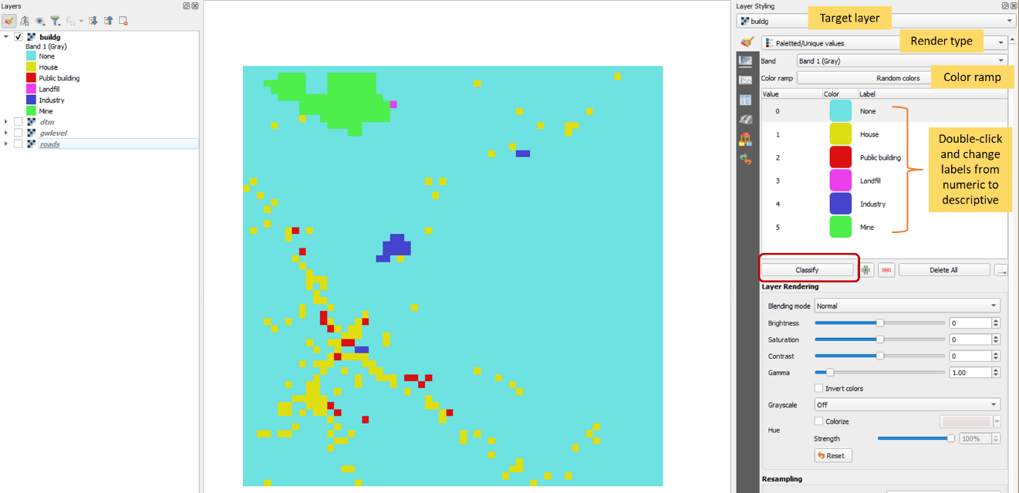
Figure 1. Styling the buildg.tif layer which is a discrete raster using the Paletted/Unique values renderer
Question #1: Is buildg a Boolean, discrete, or continuous raster layer?

2. Create a new layer that only shows houses. The resulting raster will be a Boolean layer with “True” (value = 1) for houses and “False” (value = 0) for the other classes in the building layer.
- From the main menu go to Raster – Raster Calculator.
- In the Raster Calculator (see Figure 2), double-click buildg@1, click = button, and type 1 to write the equation “buldg@1” = 1. This equation means that if in the buildg layer the value is 1 (meaning it’s a house), the output layer is True (value =1), else it is False (value = 0). This operation will create a layer containing 1 and 0, where 1 is for a house and 0 is for not a house.
- Navigate to lab8 folder and name the output layer “houses”
- Click OK to perform computation.
- You will now have another layer in the Layers panel called “houses”

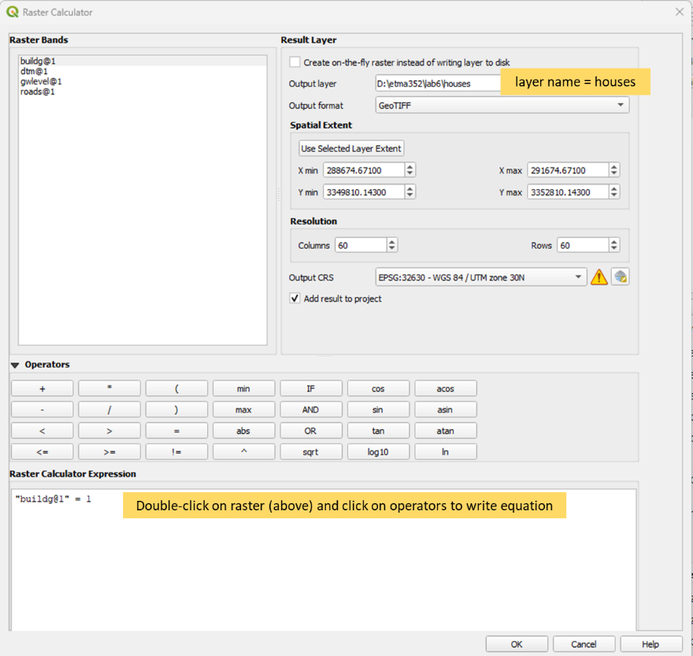
Figure 2. Using the Raster Calculator to create a Boolean map with houses.

- Style the houses layer (i.e., newly created Boolean layer)
  - Select houses layer from the dropdown arrow
  - Render type = Paletted/Unique values
  - Color ramp = Random colors – Classify
  - Doble-click the numbers under “Label” and change 0 to “Other buildings” and 1 to “House”
  - You can now see which ones were houses and which ones were not (Figure 3)

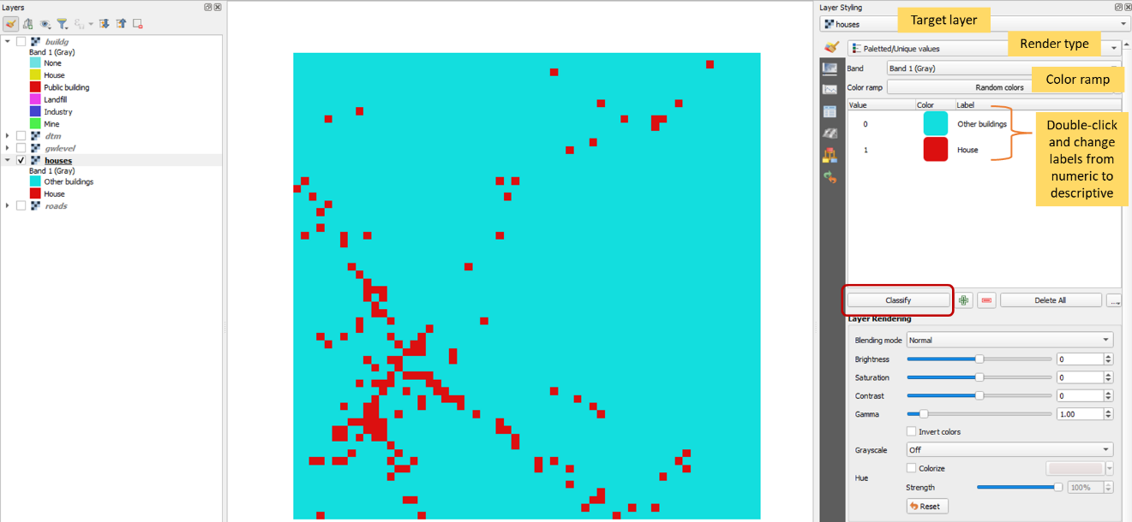
Figure 3. Styling the newly created houses layer
3. Create a buffer of 150 m around the houses.
- From the main menu, go to Raster – Analysis – Proximity (Raster Distance) (Figure 4)

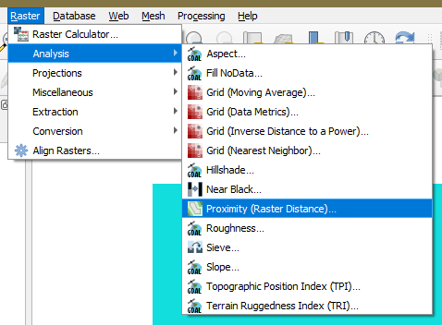
Figure 4. Proximity function
- The proximity (Raster Distance) window will open. Change the following fields (Figure 5):
  - Input layer: select houses from the dropdown arrow
  - Distance units = Georeferenced coordinates
  - Maximum distance to be generated = 150
  - Value to be applied to all pixels that are within the -maxdist of target pixels = 1
  - Output data type = byte
  - Proximity map: Browse and Save to File name it “houses150m”
  - Run
  - Close
  - You can now see the 150-m buffer around the houses.
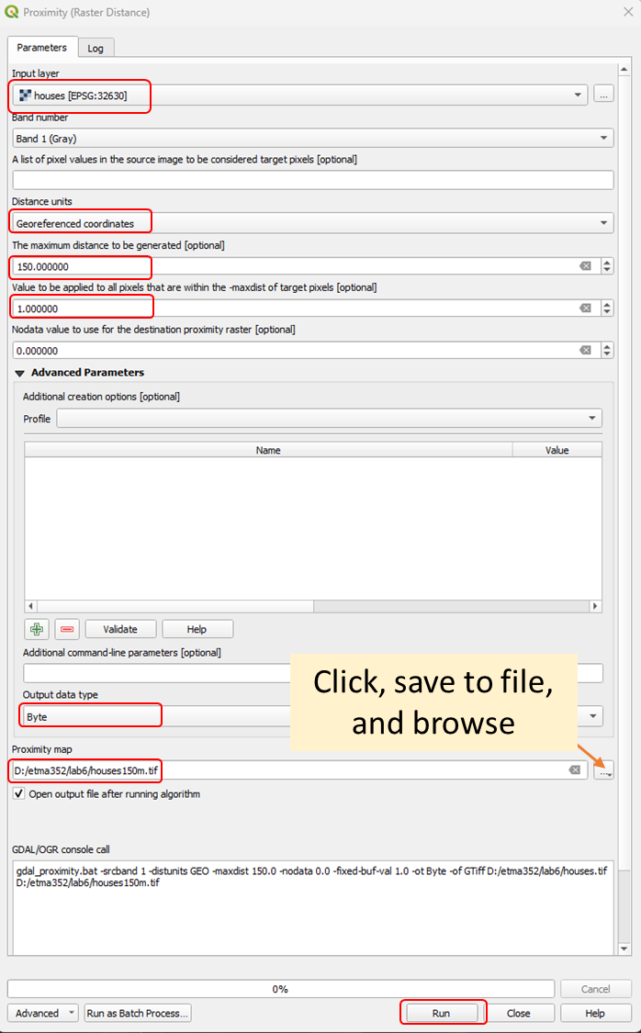
Figure 5. Proximity dialogue for 150-m buffer
- Style the houses150m layer (Figure 6):
  - Select houses150m layer from the dropdown arrow
  - Render type = Paletted/Unique values
  - Color ramp = Random colors – Classify
  - Double-click the numbers under “Label” and change 0 to “> 150 m from houses” and 1 to “< 150 m from houses”
  - Double-click on the color palette under “Color” and change the 0 value to red and the 1 value to green.

Question #2: Is houses150m a Boolean, discrete, or continuous raster layer?

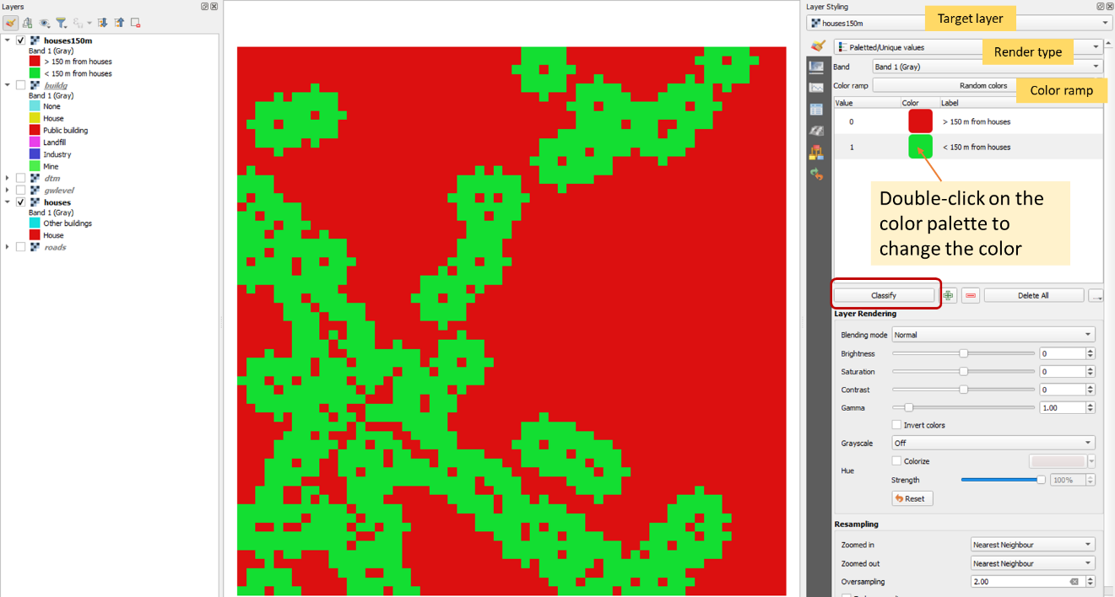
Figure 6. Styling the houses150m layer
4. Create a 150-m buffer around the roads by following the same steps when buffering the houses.
- Style the roads layer (Figure 7)
  - Select houses layer from the dropdown arrow
  - Render type = Paletted/Unique values
  - Color ramp = Random colors – Classify
  - No need to rename the roads
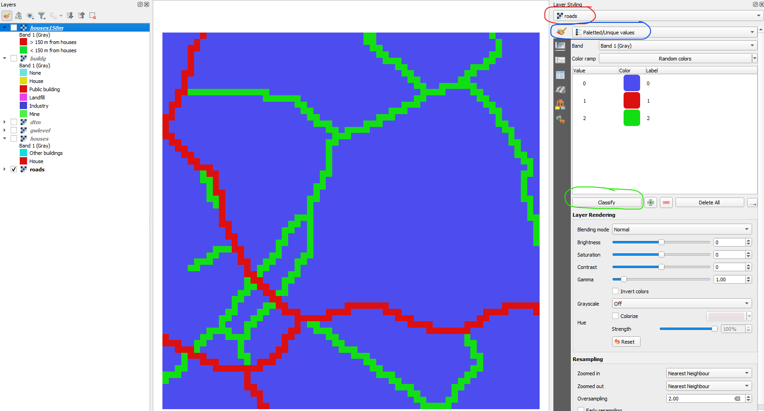
Figure 7. Styling the road layer
- Create a buffer of 150 m around the roads. From the main menu, go to Raster – Analysis – Proximity (Raster Distance) to open the Proximity window. Follow the entries in Figure 5 except for the name of the layers.
  - Input layer: select roads from the dropdown arrow
  - Distance units = Georeferenced coordinates
  - Maximum distance to be generated = 150
  - Value to be applied to all pixels that are within the -maxdist of target pixels = 1
  - Output data type = byte
  - Proximity map: Browse and Save to File name it “roads150m”
  - Run
  - Close
  - You can now see the 150-m buffer around the roads.

- Style the roads150m layer (Figure 8):
  - Select roads150m layer from the dropdown arrow
  - Render type = Paletted/Unique values
  - Color ramp = Random colors – Classify
  - Double-click the numbers under “Label” and change 0 to “> 150 m from houses” and 1 to “< 150 m from houses”
  - Double-click on the color palette under “Color” and change the 0 value to red and the 1 value to green.

Question #3: Is roads150m a Boolean, discrete, or continuous raster layer?

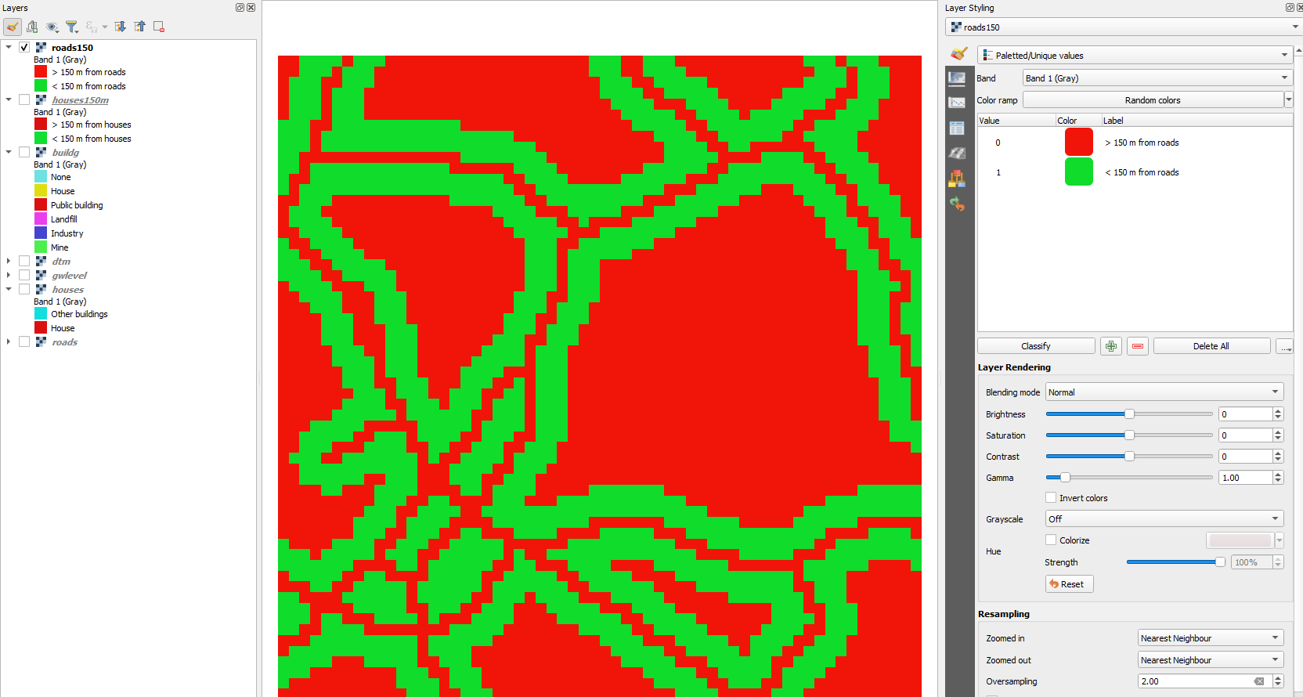
Figure 8. Styling the buffered roads layer.

Part 2 – Condition 2: No Industry, Mine, or Landfill within 300 m from wells
For the second condition, we first need to reclassify the buildg layer to create a Boolean map with True (1) for industry, mine, and landfill and False (0) for the other classes. Since the raster operation Proximity does not allow us to assign values greater than a certain threshold (e.g., greater than 300 m), we cannot use it to create a buffer as we did for houses and roads. Instead, we will calculate the distance to the true pixels to identify the wells that are further than 300 m from industry, mine, and landfill.

1. Create a Boolean raster with True (1) for industry, mine, and landfill, and False (0) for other buildings.
- From the main menu choose Processing – Toolbox. The Processing toolbox will open to the right of QGIS
- Select Raster analysis – Reclassify by table (Figure 9)
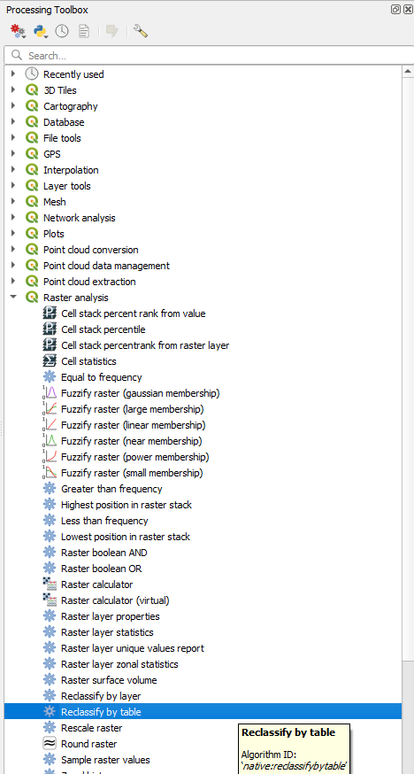
Figure 9. Reclassify by table processing tool.
- In the Reclassify by table window, specify the following (Figure 10):
  - Raster layer = buildg
  - Under Reclassify table click the browse button. This will open another window where you can create a look-up table. Add 6 rows by clicking Add Row 6 times. Fill in the values in the cells as shown in Figure 10.
  - Go back to the main window by clicking
  - Range boundaries: min < = value < = max (NOTE: the range boundaries define if the values are included or excluded from the ranges in a row of the lookup table. Here we do not use ranges but will reclassify each value, hence, we choose “min < = value < = max”
  - Output data type = Int16
  - Reclassified raster: Browse – Save as File – name the file “industry”
  - Run
  - Close

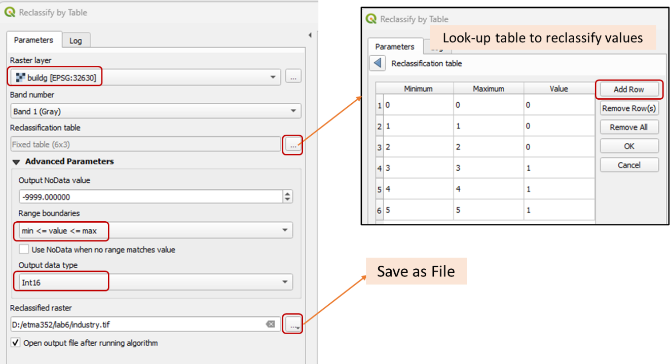
Figure 10. Reclassify by table and creating the look-up table.
  - Check the resulting layer (Figure 11): Select the industry layer in the Layers panel and uncheck the rest. Click the identify tool and click on the map. On the lower right panel, you can see the value of the pixel (1 or 0).
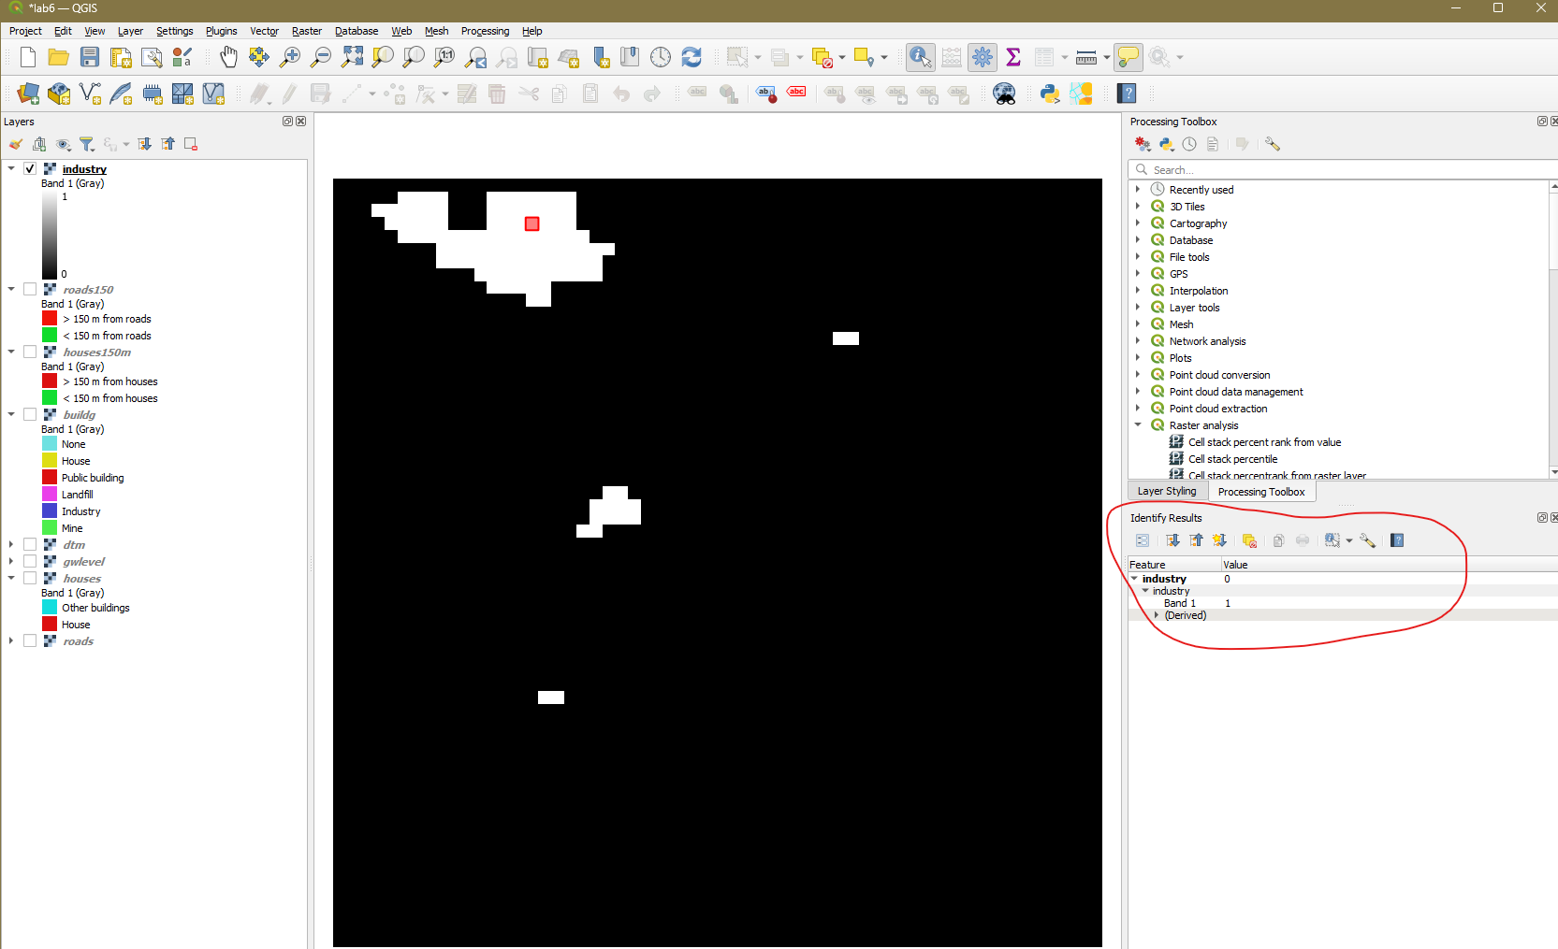
Figure 11. Boolean layer showing the industry, mine, and landfill.
2. Style the Boolean layer. Open the Layer Styling panel and specify the following:
- Select industry layer from the dropdown arrow.
- Render type = Paletted/Unique values
- Color ramp = Random colors – Classify
- Double-click the numbers under “Label” and change 0 to “not industry” and 1 to “industry”
- Double-click on the color palette under “Color” and change the 0 value to red and the 1 value to green (see Figure 12).

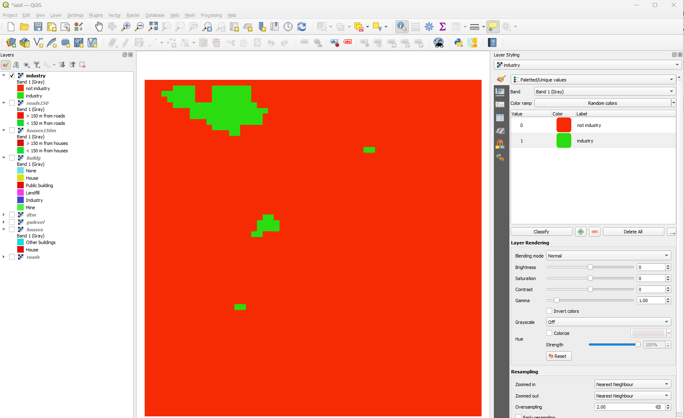
Figure 12. Styled Boolean map showing the industry
3. With the Boolean map with True (1) values for industry, mine, and landfill, we can calculate the distance to these pixels. From the main menu choose Raster – Analysis - Proximity (Raster Distance). Keep all the settings as default except for (Figure 13):
- Input layer = industry
- Distance units = Georeferenced coordinates
- Proximity map: Browse - Save as File – name the file industry_dist
- Run
- Close

Question #4: Is industry_dist a Boolean, discrete, or continuous raster layer?

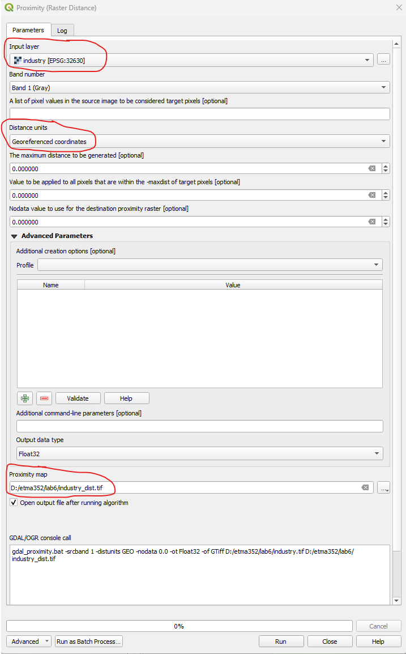
Figure 13. Computing the distance to the industry

4. Use the raster calculator to determine the distance greater than or equal to 300 m from the industry (Figure 14).
- From the main menu, choose Raster – Raster Calculator
- Double-click the industry@1 from the Raster Bands and click the >= operator to write the equation “industry_dist@1” >= 300
- Output layer = industry300
- OK

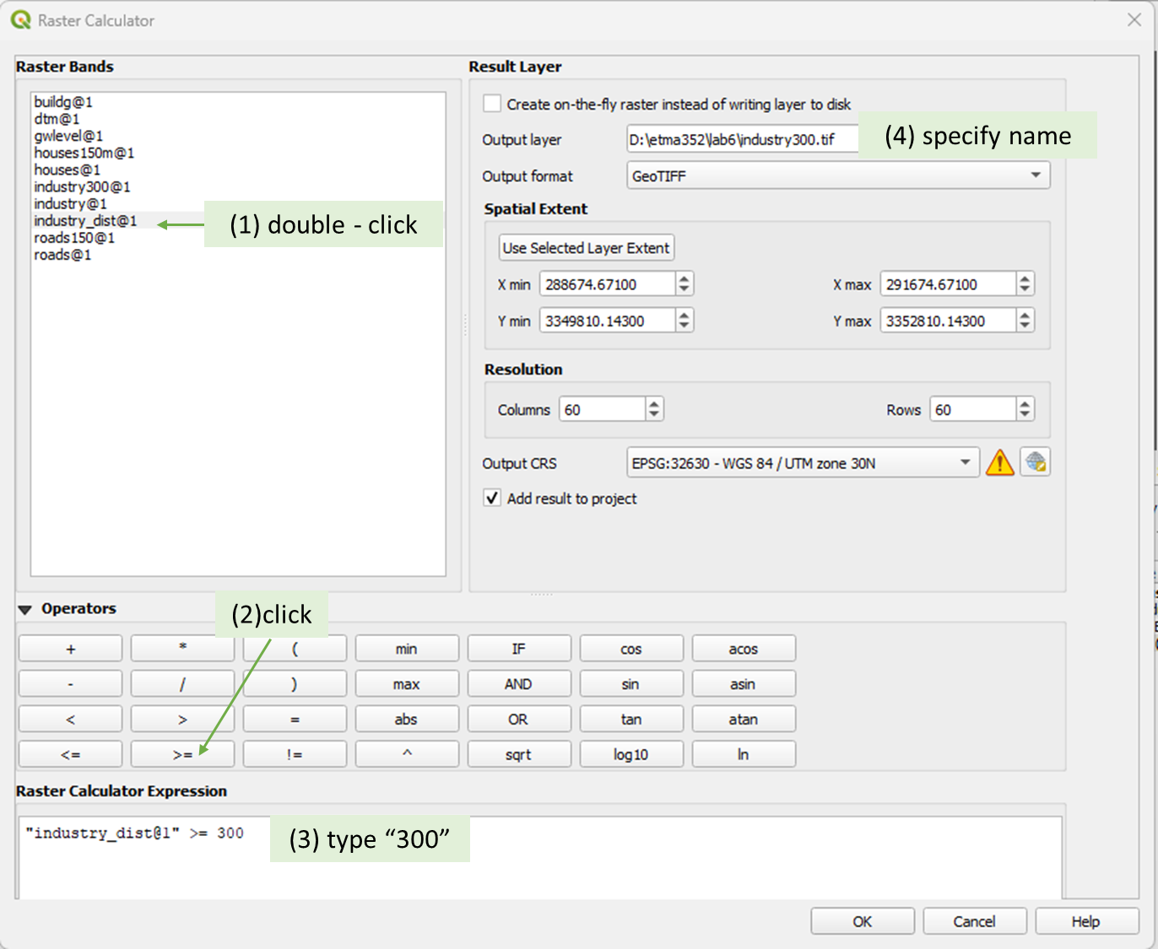
Figure 14. Identifying the pixels greater than 300 m around the industry.
4. Style the industry300 layer
- Select industry300 layer from the dropdown arrow.
- Render type = Paletted/Unique values
- Color ramp = Random colors – Classify
- Double-click the numbers under “Label” and change 0 to “< 300 m” and 1 to “>= 300 m”
- Double-click on the color palette under “Color” and change the 0 value to red and the 1 value to green (see Figure 15).
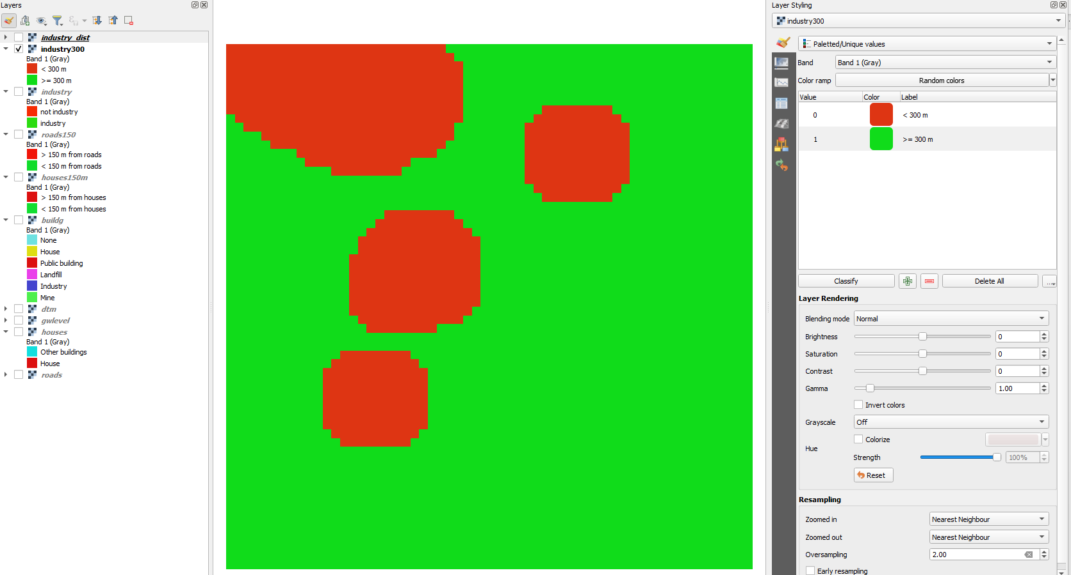
Figure 15. Result of the second condition (>= industry, mine, landfill)
Part 3 – Condition 3: Wells less than 40 m deep

For the last condition, we need to identify the wells that are less than 40 m deep. The gwlevel layer gives the absolute elevation of the water level in the wells above the mean sea level. To calculate the depth to the water level, we need to subtract the gwlevel from the surface elevation in the digital terrain model (dtm) layer.

1. From the main menu, choose Raster – Raster Calculator
2. Subtract the gwlevel layer from the dtm layer. Double-click on the layers and click the operators to write the equation “dtm@1” – “gwlevel@1”. Call the output welldepth (Figure 16).

Question #5: Is welldepth a Boolean, discrete, or continuous raster layer?

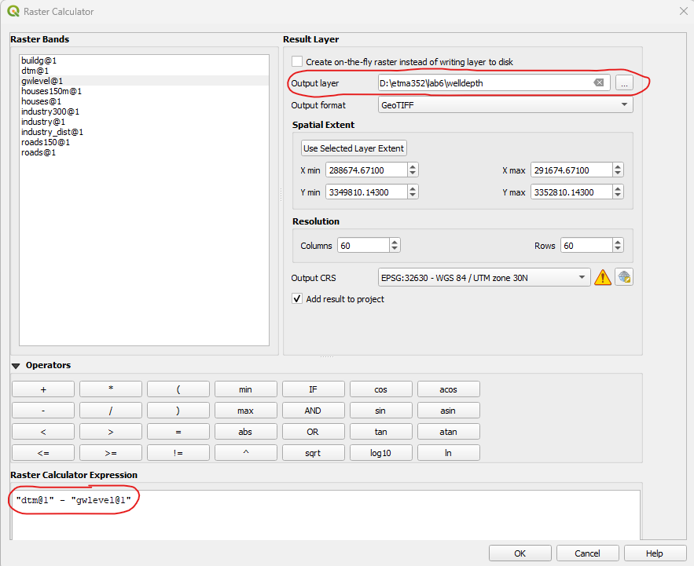
Figure 16. Computing the well depth
3. Find wells that are less than 40 m deep. We are going to create a Boolean layer that assigns True (1) to wells less than 40 m deep and False (0) to wells deeper than 40 m.
- From the main menu, choose Raster – Raster Calculator
- Write the equation welldepth@1 < 40.
- Call the output layer welldepth40 (Figure 17)

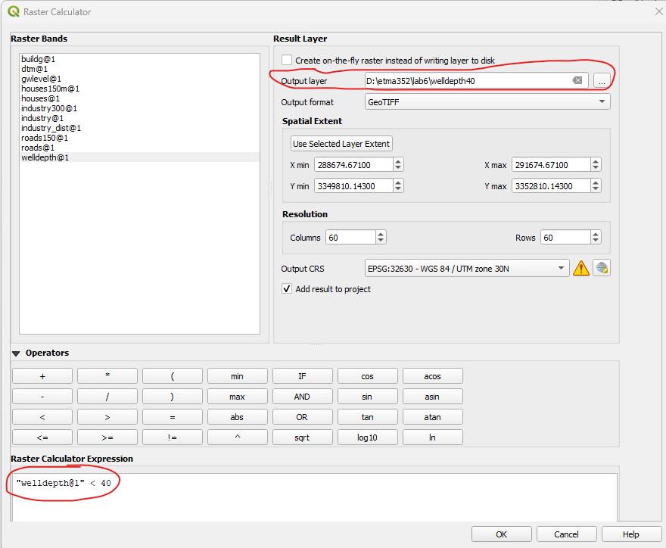
Figure 1. Identifying the wells that are less than 40 m deep

4. Style the welldepth layer (see Figure 18)
- Select the welldepth40 layer from the dropdown arrow.
- Render type = Paletted/Unique values
- Color ramp = Random colors – Classify
- Double-click the numbers under “Label” and change 0 to “deep” and 1 to “not deep”

Question #6: Is welldepth40 a Boolean, discrete, or continuous raster layer?

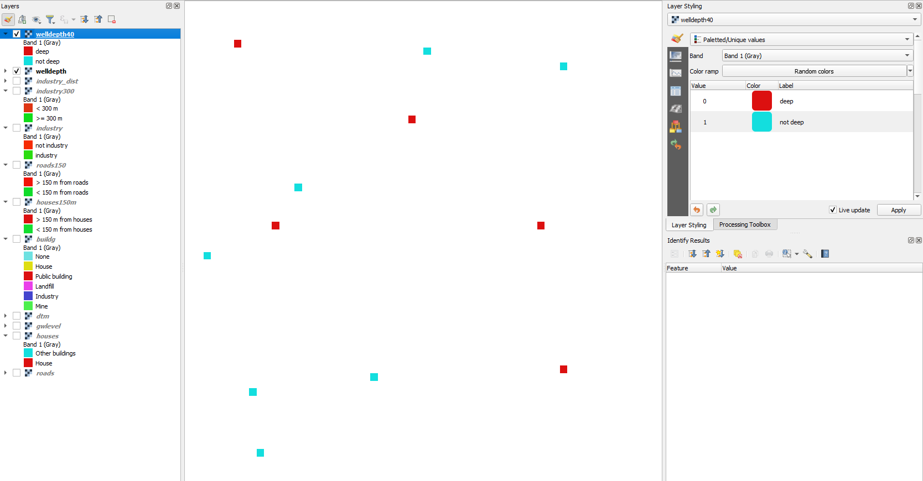
Figure 2. Result of the third condition (well < 40 m deep)
Part 4 – Combine the three conditions and prepare the final map.

1. Combine the effects of the three conditions using the Raster Calculator.
- From the main menu, choose Raster – Raster Calculator
- Combine the effects of houses150, roads150, industry300, and welldepth40 using the operator “AND” (Figure 19). Call the output layer accessiblewells.

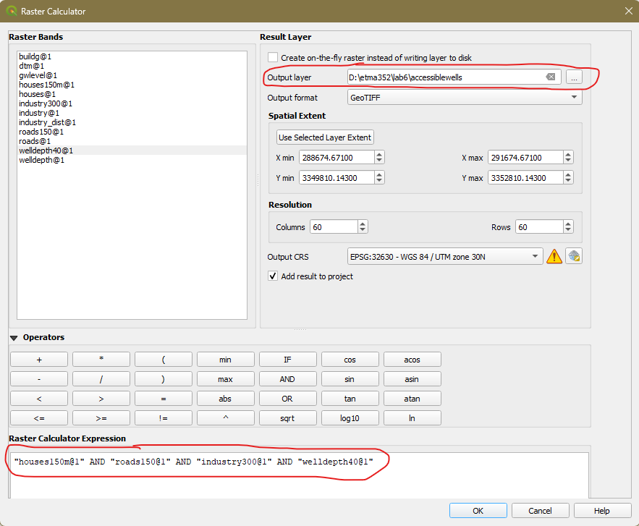
Figure 3. Calculate the combined effects of the three conditions

2. Style the accessiblewells layer:
- Select the accessiblewells layer from the dropdown arrow.
- Render type = Paletted/Unique values
- Color ramp = Random colors – Classify
- Double-click the numbers under “Label” and change 0 to “not accessible” and 1 to “accessible”

To style the final map, we will present the wells as point features on the map by first converting the well pixels to point vectors. This means that we will convert accessiblewells raster to a shapefile.

3. Convert the Raster pixels to points in a shapefile (Figure 20)
- From the main menu choose Processing – Toolbar
- From the Toolbar go to Vector Creation – Raster pixels to points

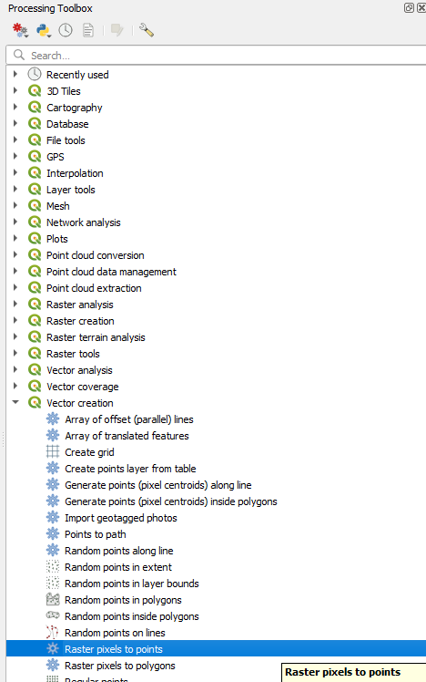
Figure 4. From raster pixels to points processing tool
- In the Raster pixel to points window, specify the following (Figure 21):
  - Raster layer: accessiblewells
  - Field name: Accessibility – The raster values will be saved under this field (column) in the attribute table.
  - Vector points: Browse – Save to File
    - File name: wells
    - Save as type: SHP files(*.shp)
  - Run
  - Close
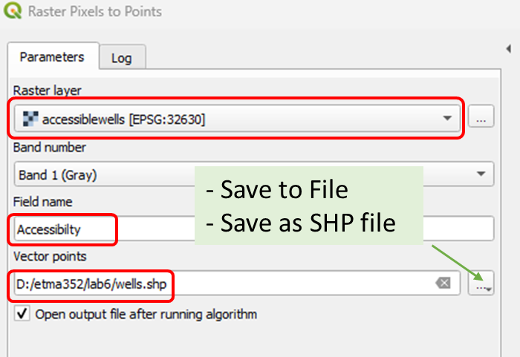

Figure 21. Raster pixel to points processing

If you open the attribute table of the wells layer, it only contains the field Accessibility showing the Boolean values (0 and 1). It is however more informative to also include other data in the attribute table. We can add more information to the points using samples from the original raster layers. We will need the Point sampling tool plugin for this purpose.

4. Install the Point sampling tool plugin (Figure 22)
- From the main menu choose Plugins – Manage and Install Plugins – Scroll and find the Point sampling tool plugin.
- Install Plugin
- Close
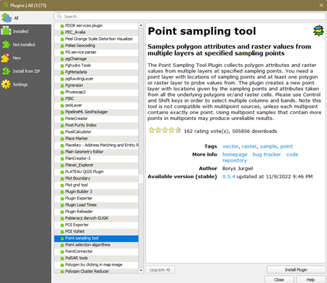
Figure 22. Installing the Point sampling tool plugin
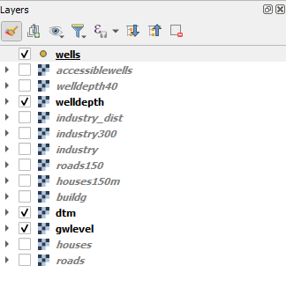
5. Add information to the wells layer
Figure 23. Layers to include
- In the Layers panel, only check the boxes before the layers you want to sample. Check only the following layers: wells, dtm, welldepth, and gwlevel (Figure 23)
- Click the Point sampling tool button from the toolbars (top) to open the window (Figure 24).
  - Layer containing sampling points: wells
  - Select all layers by holding Ctrl while clicking each layer
  - Browse and save the layer as wells_final and Save as type = Shapefiles(*.shp)
  - Click the Fields tab
  - Change the name of the fields by double-clicking and typing the new names shown in (Figure 24)
  - OK
  - Close

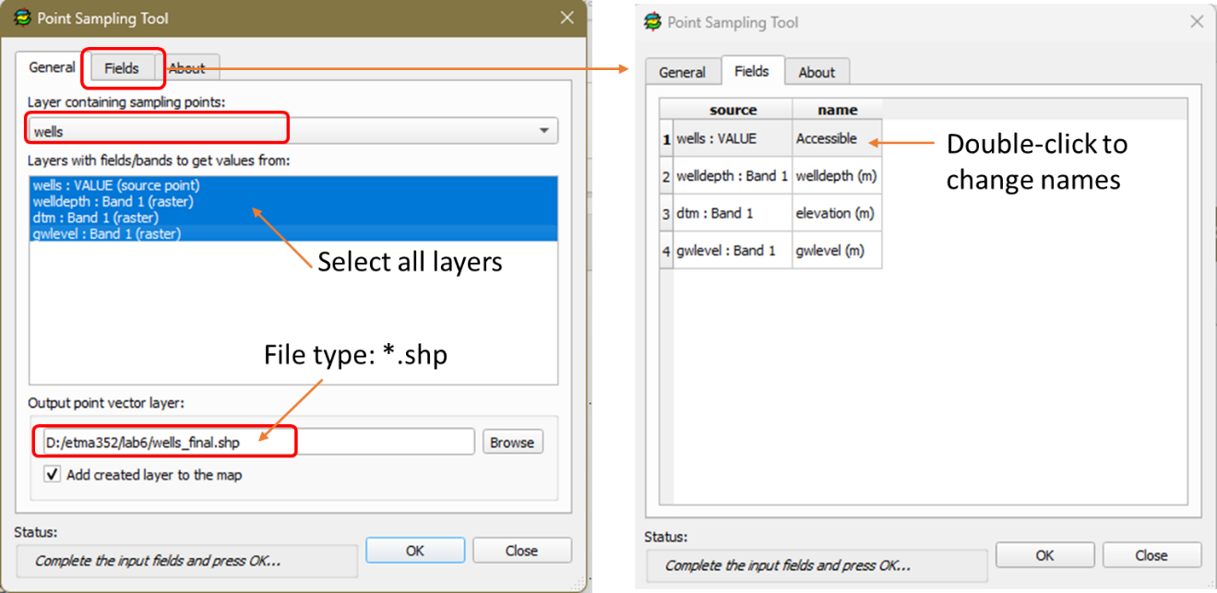
Figure 24. General and Field tabs of Point sampling tool

  - Check the attribute table of wells_final. It should contain 4 columns (Figure 25).

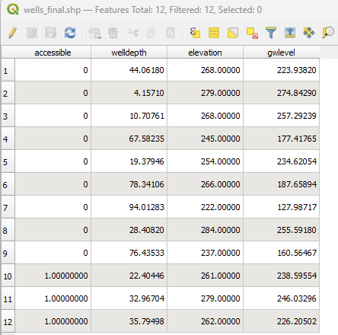
Figure 25. Attribute table of the final map
The final map will show the wells and the depth of water in the wells with the dtm (elevation) layer as the background.

6. Style the dtm layer.
  - Uncheck all the other layers in the Layers panel except the dtm layer.
  - Click the Layer Styling icon
  - Select the dtm layer from the dropdown arrow.
  - Render type = Singleband pseudocolor
  - Color ramp = ramp color of your choice – Classify

7. Style the wells_final layer (Figure 26). Check the wells_final layer in the Layers Styling panel.
- In the Layer Styling panel, select wells_final from the dropdown arrow.
- Render type: Categorized
- Value = Accessible
- Classify
- Notice that there are three Values: 0, 1, all other. Click all other and delete it by clicking
- Double-click the numbers under “Label” and change 0 to “inaccessible” and 1 to “accessible”
- Double-click the symbol for 1 and change the size to 4. You can also change the colors of the symbols if you want.

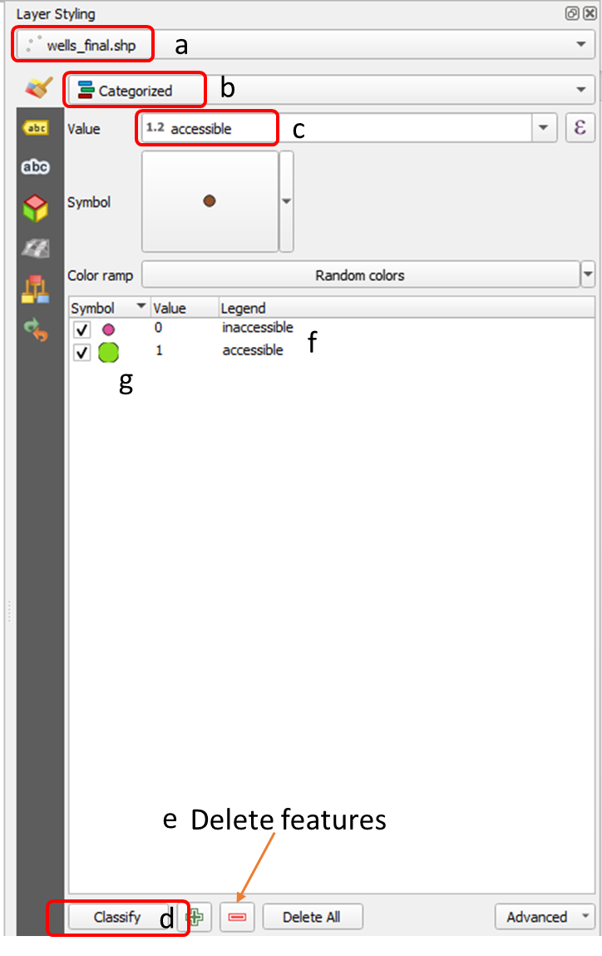
Figure 5. Styling the wells_final layer
8. Label the wells. Switch to the Labels tab of the Layer Styling panel
- Change the setting from No labels to Single labels
- Value = welldepth
- You will set the expression  up so the labels read: Well Depth (m): 75.23. You will need to:
  - Insert “Well Depth (m):” before the ‘welldepth’
  - Roundoff ‘welldepth’ to 2 decimal places
- Click the Expression button to open the Expression Dialog window (Figure 27).
  - Type ‘Well Depth (m):’ before the “welldepth” and then click the String Concatenate operator ||. Add a space by typing ‘ ‘ and then click the concatenator operator || again.
  - You will use the format_number function to roundoff. The
    - Put the cursor before “welldepth”
    - Search for format_number and double-click it. It will appear where the cursor was.
    - Remove the quotation marks around welldepth and then type , 2)
    - Check the preview or error messages at the bottom (Figure 27)
    - Click OK if preview is correct

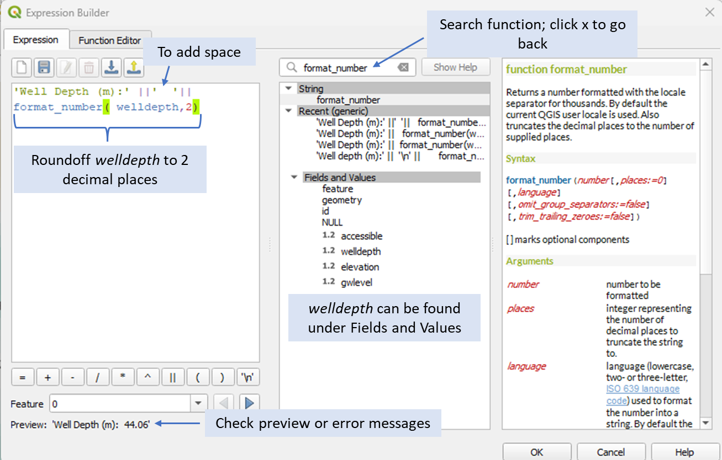
Figure 6. Writing the expression for the final label
9. Before creating a printable map, right-click on one of the layers on the Layers panel and choose Zoom to Layers or simply click . This will give you zoom in view of the layers which will transfer to the print layout. Your map should look something like in Figure 28 but with different color scheme.
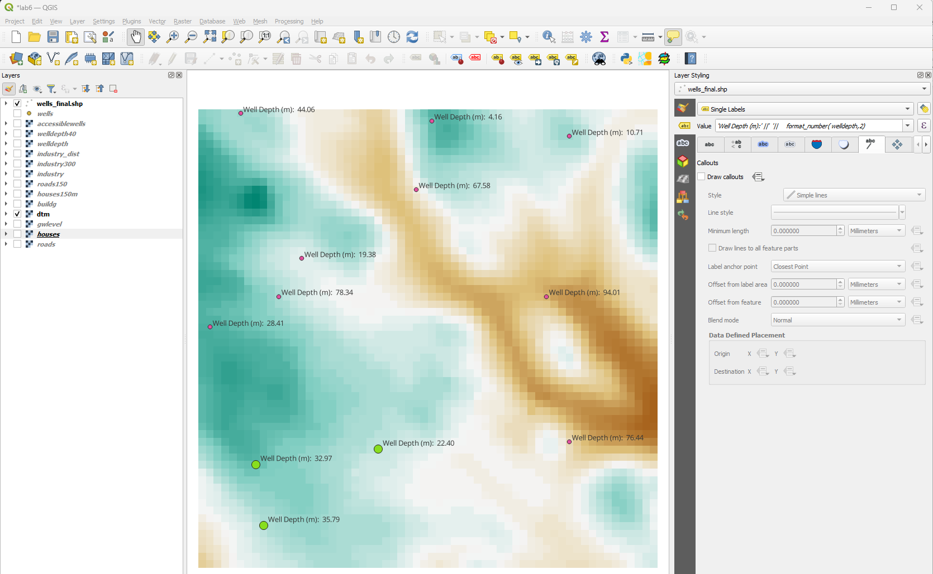
Figure 7. Final map
10. Click the New Print Layout icon 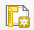 and create a printable map (see example in Figure 30). Follow the steps from the previous lab exercise. Feel free to style your printable map but make sure to insert the following elements:
- Map Title: Accessible Wells
- Your name and date
- North arrow
- Scale bar
- Legend: All layers in the Layers panel will be added when you add the legend. We only want the legend from the layers in our final map which are the wells_final.shp and dtm
  - On the Item Properties panel (right side), delete the layers that we do not want from the Legend Items. Uncheck Auto update (Figure 29a), then click the layer to delete and click . Similarly you can add layers using .
  - Delete all layers except wells_final.shp and dtm
  - Change the titles of the layers. Double click the title to make them editable (Figure 29b). Change wells_final.shp to “Accessible wells” and Band 1 (Gray) to “Elevation (m)”
  - Don’t forget to type the Title: Legend
  - The printable map should look something like in Figure 30
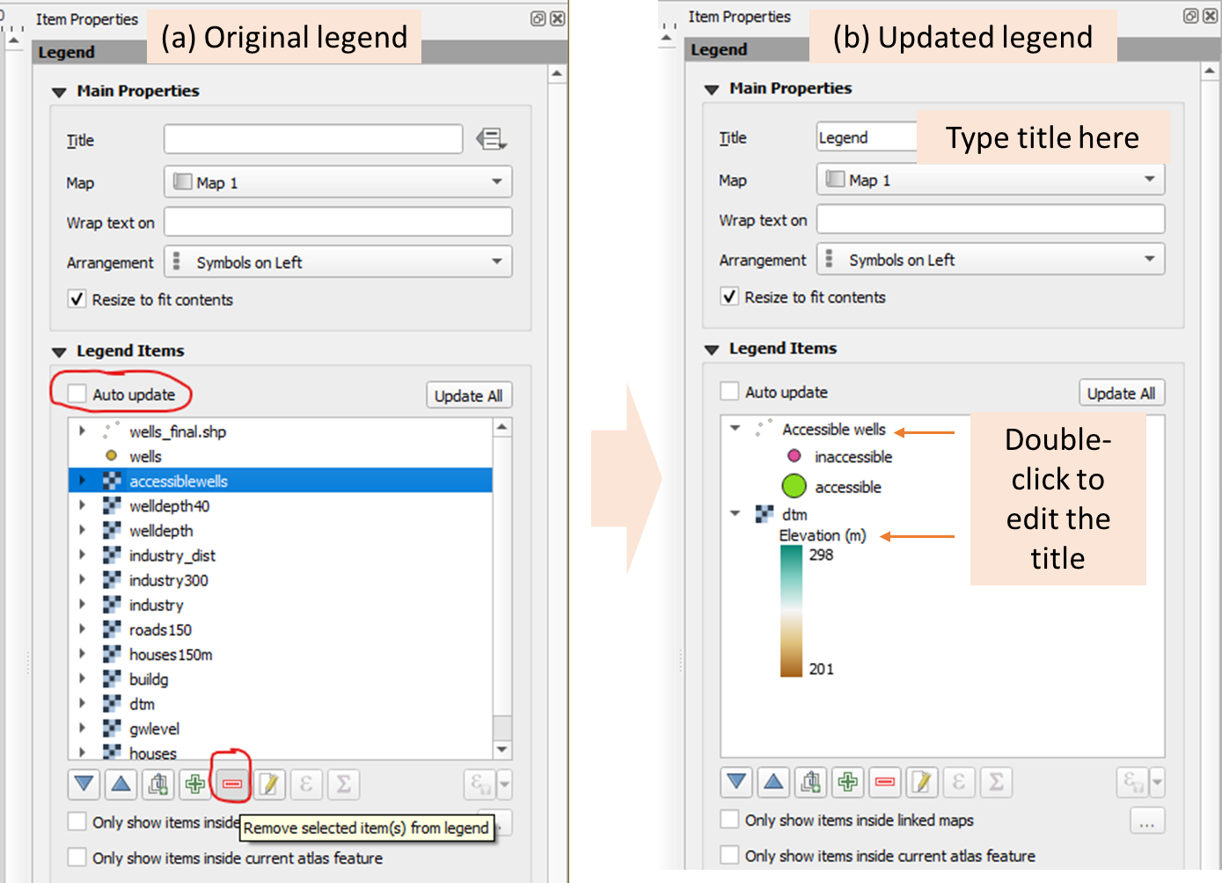
Figure 8 Add the legend
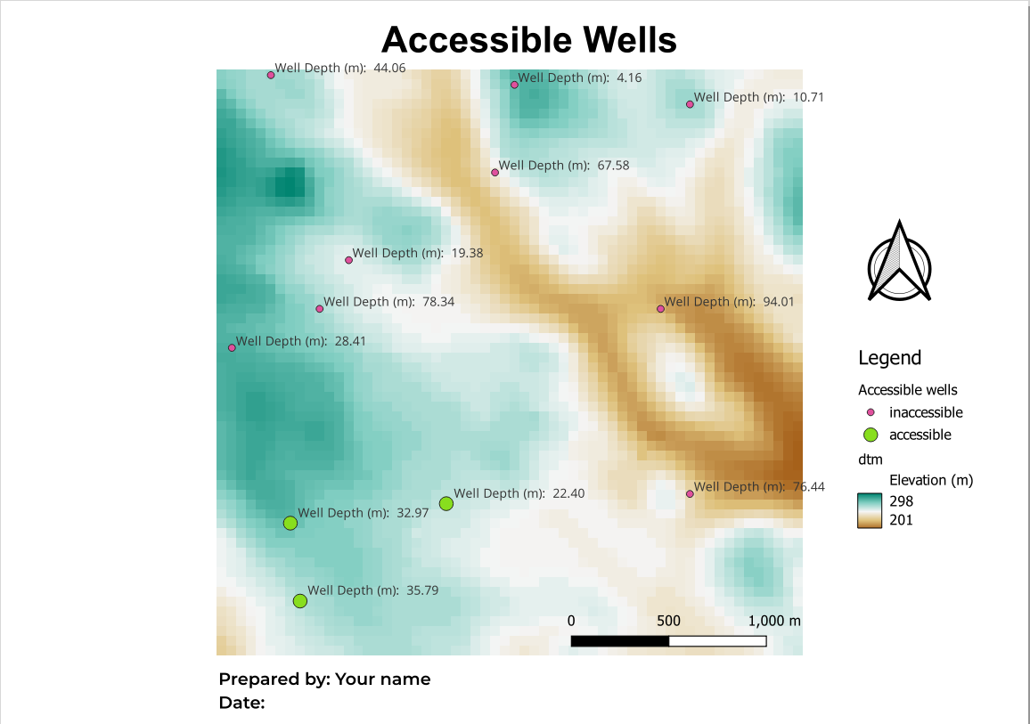
Figure 9. Final printable map
11. Export your map as an image (*.PNG) and as a PDF file following the instructions in the previous lab.

